沈阳航空航天大学

**计算机网络原理**

**实 验 报 告**

实验题目：实验一 组网基础实验

实验二 交换机及虚拟局域网的配置

实验三 网络互连综合实验

院（系）：人工智能学院

专 业：物联网工程

班 级：物联网2202

学 号：223428010210

姓 名：陈梓欣

指导教师：王岩

## 实验一 组网基础实验

1. 小组成员

小组成员：陈梓欣、明鑫、尹璐、郑羽婷、曲文新。

所属组别：E组。

2. 实验目的

1. 熟练掌握双绞线等网络传输媒体的制作、测试技术。
2. 熟悉常用网络命令。
3. 熟悉主机 1P 地址配置方法。

3．实验内容和步骤

3.1 网线制作

双绞线线序为：橙白，橙，绿白，蓝，蓝白，绿，棕白，棕

制作步骤：

首先剪双绞线，剥皮，排序按 T568B 的顺序，用钳子剪齐，插入水晶头，用专用的钳子压制。制作效果如图1网线制作示例所示。

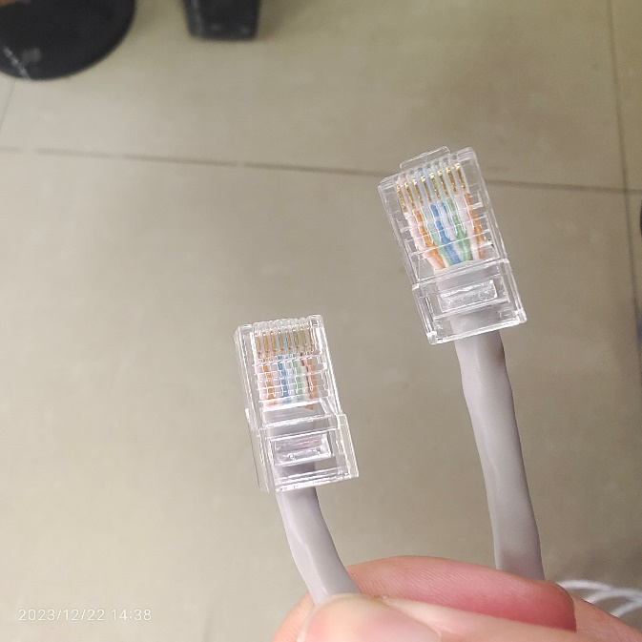

**图1.1 网线制作示例**

将做好的网线的两头分别插入网线测试仪中，并启动开关，如果两边的指示灯亮起且跑马同步，则表示网线制作成功。测试结果如图2网线可用性测试所示。

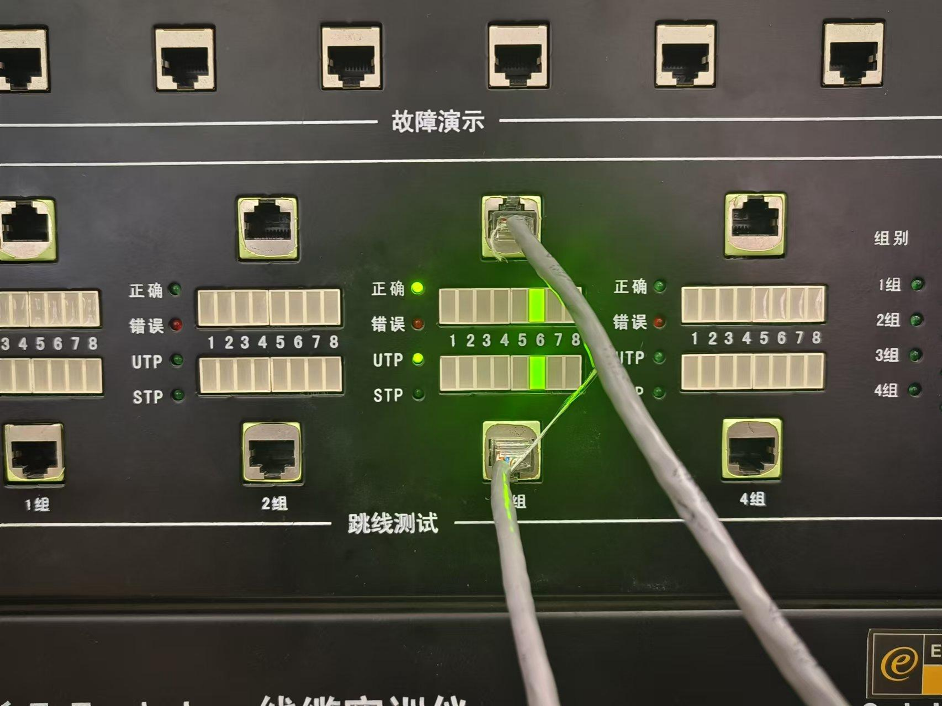

**图1.2 网线可用性测试**

3.2 常用网络命令的使用

1. 写出Ping功能，使用命令并截图。

功能：Ping是一种网络工具，用于测试主机之间的连通性。它发送一个ICMP回显请求到指定的目标主机，并等待接收回显响应。

文本

**图1.3 ping命令**

1. 写出ipconfig /all 的功能，使用命令并截图。

功能：显示所有网络接口的详细信息，可以打印有关计算机网络配置的详尽信息，包括网络适配器、IP地址、子网掩码、网关、DNS服务器、物理地址（MAC地址）和其他网络配置信息。

**图1.4 ipconfig /all命令**

1. 写出arp –a的功能，使用命令并截图。

功能：显示已解析的IP地址到MAC地址的映射，列出计算机中ARP缓存中保存的IP地址与MAC地址的映射关系；

显示网络中的设备，展示与计算机相邻连接的其他设备的MAC地址和对应的IP地址；

用于网络排查和故障排除：ARP缓存允许用户查看最近使用过的IP地址和MAC地址的映射，有助于识别网络中设备的连接和通信状态；

提供网络映射信息，能够查看已知设备的MAC地址和IP地址的映射是很有用的，可以检查这些映射是否与预期一致。

**图1.5 arp-a命令**

1. 写出tracert的功能，使用命令并截图。

功能：追踪数据包的路径，它向目标主机发送数据包，并记录每个节点（路由器或服务器）的响应时间；

显示每个节点的延迟，tracert 显示数据包经过的每个路由器（或主机）的IP地址，并记录到达每个节点所需的时间（以毫秒为单位）；

确定数据包路径，跟踪数据包穿越互联网的路径，有助于了解数据包从源到目的地所经过的网络路径，以及每个节点的响应时间；

**图1.6 tracert命令**

3.3 主机IP地址基本配置方法

写出主机IP地址基本配置方法

连接简单局域网并对主机IP地址进行配置为192.168.1.56，对子网掩码配置为255.255.255.0，删掉初始默认网关如图1.7。

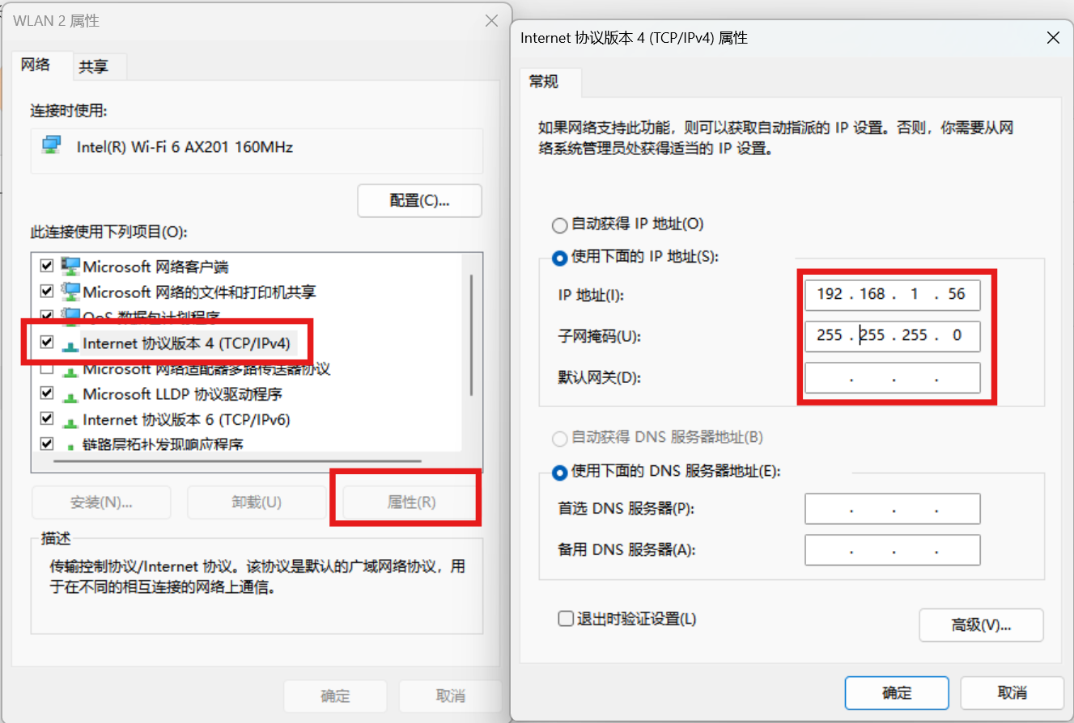

**图1.7 主机IP配置示例**

## 实验二 交换机及虚拟局域网的配置

1. 小组成员

小组成员：陈梓欣、明鑫、尹璐、郑羽婷、曲文新。

所属组别：E组。

2. 实验目的

1. 掌握交换机各种命令行操作模式的区别，以及各模式间切换方法。
2. 学习交换机的管理特性及命令行操作，掌握交换机的基本配置方法。
3. 掌握交换机系统和配置信息的查看方法，获取交换机的当前工作状态。
4. 掌握交换机VLAN的配置方法。

3．实验内容和步骤

实验2.1

画出所用的网络拓扑结构图。

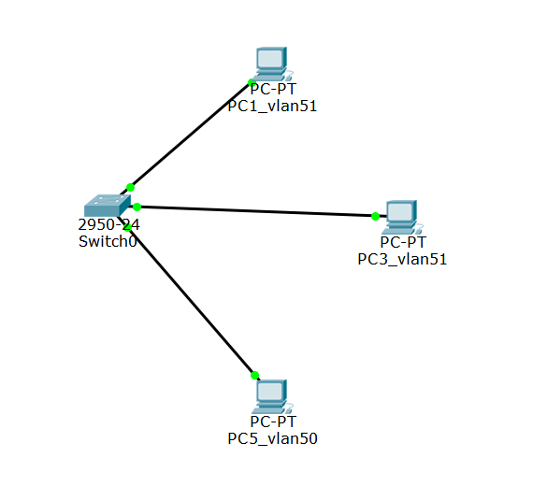

**图2.1 交换机VLAN实验拓扑**

写出：

1. 所有的配置过程。（如实验过程中遇到问题，写出问题原因及解决方法）
2. 首先先配置主机IP地址，打开Internet协议版本4的属性，将IP地址改为192.168.1.56，子网掩码为255.255.255.0
3. 然后在Web页面的形式登录到系统的控制平台，登陆网址是：http://192.168.1.30:8080。选择你所要操作的硬件设备，点击直接进入其操作界面，按PPT指令开始配置。

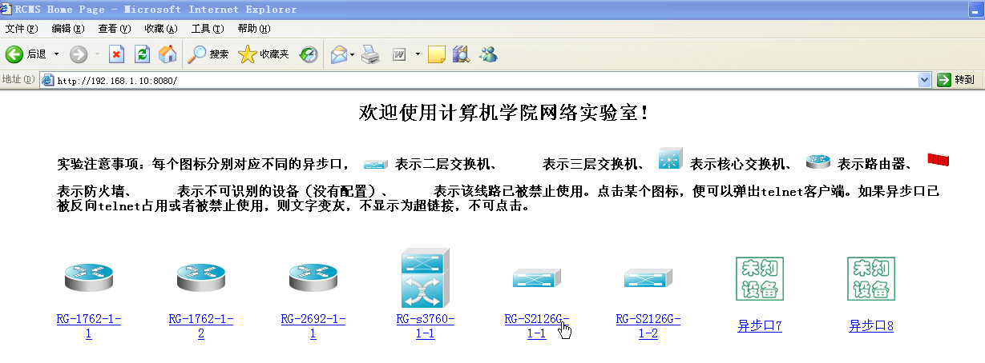

**图2.2 系统的控制平台**

1. 选定设备，进行配置。具体配置指令如下：

建立一个VLAN 51

Switch(config)#vlan 51

Switch(config-vlan)#name vlan51

Switch(config-vlan)#exit

把端口fastethernet 0/1加入进vlan 51

Switch(config)# interface fastethernet 0/1

Switch(config-if)# switchport access vlan 51

把端口fastethernet 0/2加入进vlan 51

Switch(config)# interface fastethernet 0/2

Switch(config-if)# switchport access vlan 51

建立一个VLAN 50

Switch(config)#vlan 50

Switch(config-vlan)#name vlan50

Switch(config-vlan)#exit

把端口fastethernet 0/3加入进vlan 50

Switch(config)# interface fastethernet 0/3

Switch(config-if)# switchport access vlan 50

1. 写出配置成功后，每台设备执行“show vlan”和“show running-config”后的结果。
2. Switch#show vlan

VLAN Name Status Ports

---- -------------------------------- --------- -------------------------------

1 default active Fa0/4, Fa0/5, Fa0/6, Fa0/7

Fa0/8, Fa0/9, Fa0/10, Fa0/11

Fa0/12, Fa0/13, Fa0/14, Fa0/15

Fa0/16, Fa0/17, Fa0/18, Fa0/19

Fa0/20, Fa0/21, Fa0/22, Fa0/23

Fa0/24

50 vlan50 active Fa0/3

51 vlan51 active Fa0/1, Fa0/2

1002 fddi-default act/unsup

1003 token-ring-default act/unsup

1004 fddinet-default act/unsup

1005 trnet-default act/unsup

VLAN Type SAID MTU Parent RingNo BridgeNo Stp BrdgMode Trans1 Trans2

---- ----- ---------- ----- ------ ------ -------- ---- -------- ------ ------

1 enet 100001 1500 - - - - - 0 0

50 enet 100050 1500 - - - - - 0 0

51 enet 100051 1500 - - - - - 0 0

1002 fddi 101002 1500 - - - - - 0 0

1003 tr 101003 1500 - - - - - 0 0

1004 fdnet 101004 1500 - - - ieee - 0 0

1005 trnet 101005 1500 - - - ibm - 0 0

Remote SPAN VLANs

------------------------------------------------------------------------------

Primary Secondary Type Ports

------- --------- ----------------- ------------------------------------------

1. Switch#show running-config

Building configuration...

Current configuration : 1058 bytes

!

version 12.1

no service timestamps log datetime msec

no service timestamps debug datetime msec

no service password-encryption

!

hostname Switch

!

!

!

spanning-tree mode pvst

!

interface FastEthernet0/1

switchport access vlan 51

!

interface FastEthernet0/2

switchport access vlan 51

!

interface FastEthernet0/3

switchport access vlan 50

!

interface FastEthernet0/4

!

interface FastEthernet0/5

!

interface FastEthernet0/6

!

interface FastEthernet0/7

!

interface FastEthernet0/8

!

interface FastEthernet0/9

!

interface FastEthernet0/10

!

interface FastEthernet0/11

!

interface FastEthernet0/12

!

interface FastEthernet0/13

!

interface FastEthernet0/14

!

interface FastEthernet0/15

!

interface FastEthernet0/16

!

interface FastEthernet0/17

!

interface FastEthernet0/18

!

interface FastEthernet0/19

!

interface FastEthernet0/20

!

interface FastEthernet0/21

!

interface FastEthernet0/22

!

interface FastEthernet0/23

!

interface FastEthernet0/24

!

interface Vlan1

no ip address

shutdown

!

!

!

!

line con 0

!

line vty 0 4

login

line vty 5 15

login

!

!

end

1. 测试连通性的结果（截图）。
2. 网络设备配置好后，对选定的测试主机，禁用“本地连接3”，启用“本地连接4”,并按照实验拓扑图修改1P地址:

**表2.1 选定测试机IP及划分VLAN**

|  |  |  |
| --- | --- | --- |
| PC | IP | VLAN |
| PC1_vlan51 | 192.168.51.1 | VLAN 51 |
| PC3_vlan51 | 192.168.51.3 | VLAN 51 |
| PC5_vlan50 | 192.168.50.5 | VLAN 50 |

1. 通过网络命令进行测试（ping命令）:

* 同一个VLAN内主机的连通性

PC1_vlan51:

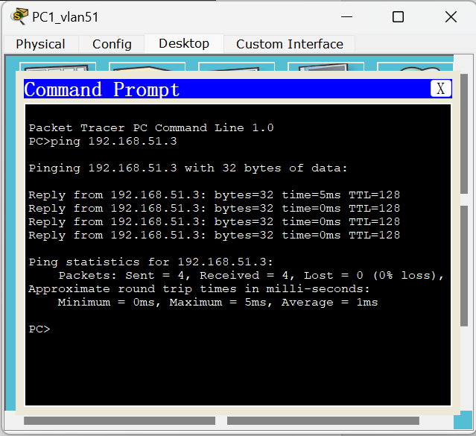

**图2.3 PC1_vlan51测试机相同VLAN主机连通性测试**

PC3_vlan51:

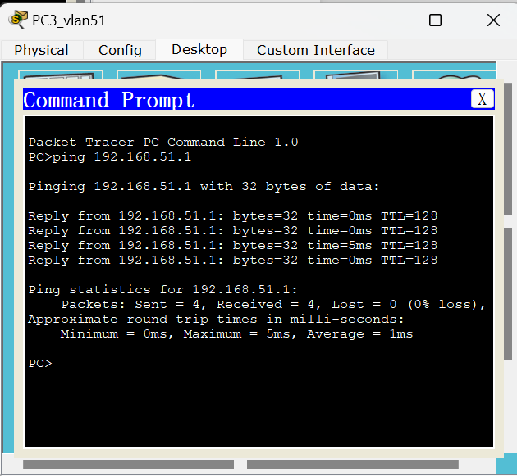

**图2.4 PC3_vlan51测试机相同VLAN主机连通性测试**

* 不同VLAN主机的连通性

PC1_vlan51:

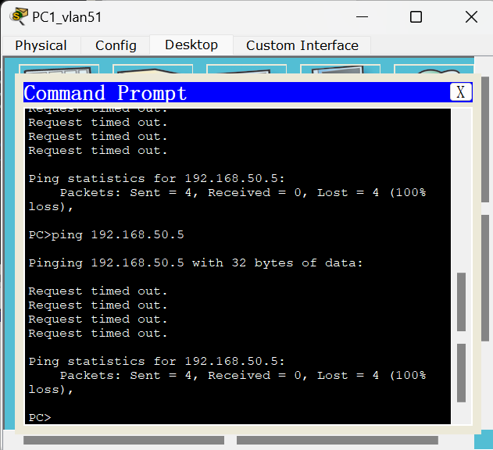

**图2.5 PC1_vlan51测试机不同VLAN主机连通性测试**

PC3_vlan51:

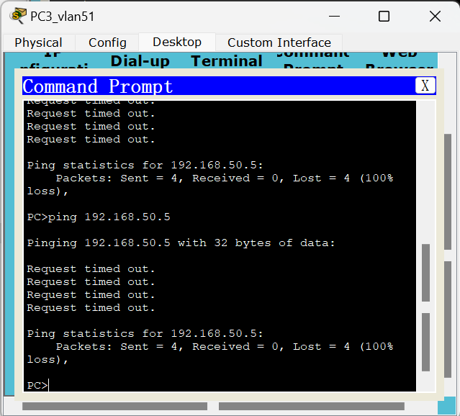

**图2.6 PC3_vlan51测试机不同VLAN主机连通性测试**

PC5_vlan50:

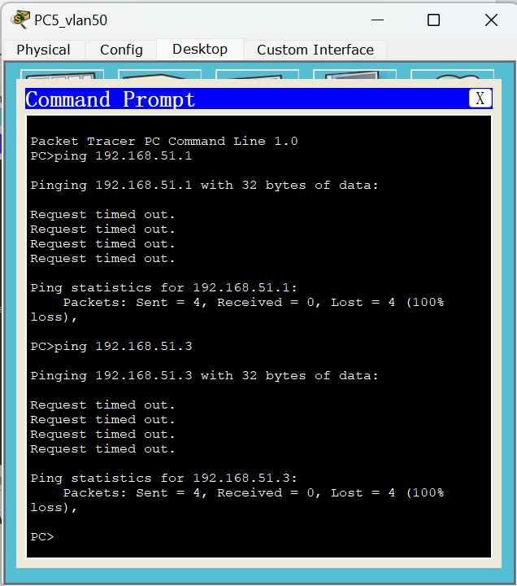

**图2.7 PC5_vlan50测试机不同VLAN主机连通性测试**

实验2.2

画出所用的网络拓扑结构图。

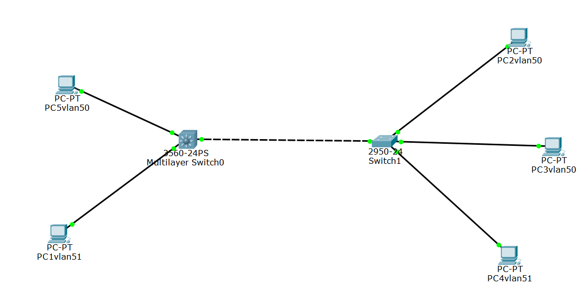

**图2.8 跨交换机实现VLAN实验拓扑**

写出：

1. 所有的配置过程。（如实验过程中遇到问题，写出问题原因及解决方法）

在交换机A上：

switch0>en

switch0#config terminal

Enter configuration commands, one per line. End with CNTL/Z.

修改交换机名称为switchA

switch0(config)#ho switchA

建立一个VLAN 50

switchA(config)#vlan 50

switchA(config-vlan)#na vlan50

把端口fastethernet 0/1加入进vlan 50

switchA(config-vlan)#in fa 0/1

switchA(config-if)#switchport access vlan 50

switchA(config-if)#exit

建立一个VLAN 51

switchA(config)#vlan 51

switchA(config-vlan)#na vlan51

把端口fastethernet 0/2加入进vlan 51

switchA(config-vlan)#in fa 0/2

switchA(config-if)#switchport access vlan 51

switchA(config-if)#exit

switchA(config)#in fa 0/3

switchA(config-if)#exit

switchA(config)#exit

创建虚拟接口vlan 50

switchA(config)#in vlan 50

switchA(config-if)#

%LINK-5-CHANGED: Interface Vlan50, changed state to up

%LINEPROTO-5-UPDOWN: Line protocol on Interface Vlan50, changed state to up

配置虚拟接口vlan 50的IP地址192.168.50.1

switchA(config-if)#ip address 192.168.50.1 255.255.255.0

开启端口

switchA(config-if)#no shutdown

switchA(config-if)#exit

创建虚拟接口vlan 51

switchA(config)#in vlan 51

switchA(config-if)#

%LINK-5-CHANGED: Interface Vlan51, changed state to up

%LINEPROTO-5-UPDOWN: Line protocol on Interface Vlan51, changed state to up

配置虚拟接口vlan 51的IP地址192.168.51.1

switchA(config-if)#ip address 192.168.51.1 255.255.255.0

开启端口

switchA(config-if)#no shutdown

switchA(config-if)#exit

在交换机B上：

switch1#config terminal

Enter configuration commands, one per line. End with CNTL/Z.

修改交换机名称为 switchB

switch1(config)#ho switchB

建立一个VLAN 50

switchB(config)#vlan 50

switchB(config-vlan)#na vlan50

把端口fastethernet 0/2加入进vlan 50

switchB(config-vlan)#in fa 0/2

switchB(config-if)#switchport access vlan 50

把端口fastethernet 0/4加入进vlan 50

switchB(config-vlan)#in fa 0/4

switchB(config-if)#switchport access vlan 50

switchB(config-if)#exit

建立一个VLAN 51

switchB(config)#vlan 51

switchB(config-vlan)#na vlan51

把端口fastethernet 0/1加入进vlan 51

switchB(config-vlan)#in fa 0/1

switchB(config-if)#switchport access vlan 51

switchB(config-if)#exit

把两个交换机相连的端口fastethernet 0/3设置为trunk方式

switchB(config)#in fa 0/3

switchB(config-if)#switchport mode trunk

switchB(config-if)#exit

switchB(config)#exit

创建虚拟接口vlan 50

switchB(config)#in vlan 50

switchB(config-if)#

%LINK-5-CHANGED: Interface Vlan50, changed state to up

%LINEPROTO-5-UPDOWN: Line protocol on Interface Vlan50, changed state to up

配置虚拟接口vlan 50的IP地址192.168.50.2

switchB(config-if)#ip address 192.168.50.2 255.255.255.0

开启端口

switchB(config-if)#no shutdown

switchB(config-if)#exit

创建虚拟接口vlan 51

switchB(config)#in vlan 51

switchB(config-if)#

%LINK-5-CHANGED: Interface Vlan51, changed state to up

%LINEPROTO-5-UPDOWN: Line protocol on Interface Vlan51, changed state to up

配置虚拟接口vlan 50的IP地址192.168.50.2

switchB(config-if)#ip address 192.168.51.2 255.255.255.0

开启端口

switchB(config-if)#no shutdown

switchB(config-if)#exit

1. 写出配置成功后，每台设备执行“show running-config”后的结果。
2. 交换机A

switchA#show running-config

Building configuration...

Current configuration : 1365 bytes

!

version 12.2

no service timestamps log datetime msec

no service timestamps debug datetime msec

no service password-encryption

!

hostname switchA

!

!

!

!

!

!

!

!

!

!

!

!

!

!

!

!

!

!

!

!

spanning-tree mode pvst

!

!

!

!

!

!

interface FastEthernet0/1

switchport access vlan 50

duplex half

speed 10

!

interface FastEthernet0/2

switchport access vlan 51

duplex half

speed 10

!

interface FastEthernet0/3

duplex half

speed 10

!

interface FastEthernet0/4

!

interface FastEthernet0/5

!

interface FastEthernet0/6

!

interface FastEthernet0/7

!

interface FastEthernet0/8

!

interface FastEthernet0/9

!

interface FastEthernet0/10

!

interface FastEthernet0/11

!

interface FastEthernet0/12

!

interface FastEthernet0/13

!

interface FastEthernet0/14

!

interface FastEthernet0/15

!

interface FastEthernet0/16

!

interface FastEthernet0/17

!

interface FastEthernet0/18

!

interface FastEthernet0/19

!

interface FastEthernet0/20

!

interface FastEthernet0/21

!

interface FastEthernet0/22

!

interface FastEthernet0/23

!

interface FastEthernet0/24

!

interface GigabitEthernet0/1

!

interface GigabitEthernet0/2

!

interface Vlan1

no ip address

shutdown

!

interface Vlan50

ip address 192.168.50.1 255.255.255.0

!

interface Vlan51

ip address 192.168.51.1 255.255.255.0

!

ip classless

!

ip flow-export version 9

!

!

!

!

!

!

!

line con 0

!

line aux 0

!

line vty 0 4

login

!

!

!

end

1. 交换机B

switchB#show running-config

Building configuration...

Current configuration : 1290 bytes

!

version 12.1

no service timestamps log datetime msec

no service timestamps debug datetime msec

no service password-encryption

!

hostname switchB

!

!

!

spanning-tree mode pvst

!

interface FastEthernet0/1

switchport access vlan 51

duplex half

speed 10

!

interface FastEthernet0/2

switchport access vlan 50

duplex half

speed 10

!

interface FastEthernet0/3

switchport mode trunk

duplex half

speed 10

!

interface FastEthernet0/4

switchport access vlan 50

duplex half

speed 10

!

interface FastEthernet0/5

!

interface FastEthernet0/6

!

interface FastEthernet0/7

!

interface FastEthernet0/8

!

interface FastEthernet0/9

!

interface FastEthernet0/10

!

interface FastEthernet0/11

!

interface FastEthernet0/12

!

interface FastEthernet0/13

!

interface FastEthernet0/14

!

interface FastEthernet0/15

!

interface FastEthernet0/16

!

interface FastEthernet0/17

!

interface FastEthernet0/18

!

interface FastEthernet0/19

!

interface FastEthernet0/20

!

interface FastEthernet0/21

!

interface FastEthernet0/22

!

interface FastEthernet0/23

!

interface FastEthernet0/24

!

interface Vlan1

no ip address

shutdown

!

interface Vlan50

ip address 192.168.50.2 255.255.255.0

!

interface Vlan51

ip address 192.168.51.2 255.255.255.0

!

!

!

!

line con 0

!

line vty 0 4

login

line vty 5 15

login

!

!

end

1. 测试连通性的结果（截图）。
2. 网络设备配置好后，对选定的测试主机，禁用“本地连接3”，启用“本地连接4”,并按照实验拓扑图修改1P地址

**表2.2 选定测试主机IP、划分VLAN以及连接的交换机与端口**

|  |  |  |  |  |
| --- | --- | --- | --- | --- |
| PC | IP | VLAN | Switch | Fastethernet |
| PC5vlan50 | 192.168.50.5 | VLAN 50 | switchA | Fa 0/1 |
| PC1vlan51 | 192.168.51.11 | VLAN 51 | switchA | Fa 0/2 |
| PC2vlan50 | 192.168.50.22 | VLAN 50 | switchB | Fa 0/2 |
| PC3vlan50 | 192.168.50.3 | VLAN 50 | switchB | Fa 0/4 |
| PC4vlan51 | 192.168.51.4 | VLAN 51 | switchB | Fa 0/1 |
| 作为两个交换机相连的端口，将其设置为trunk方式 | | | | Fa 0/3 |

1. 通过网络命令进行测试（ping命令）:

* 不同交换机内同一个VLAN内主机的连通性

PC5vlan50：

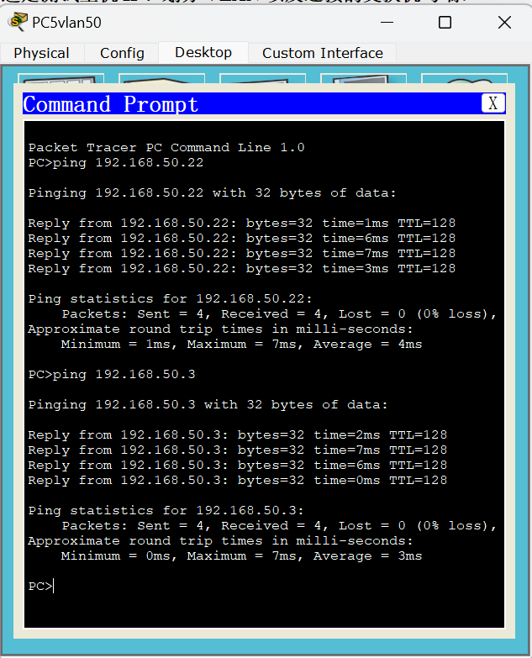

**图2.9 PC5vlan50测试机跨交换机相同VLAN主机连通性测试**

PC4vlan51：

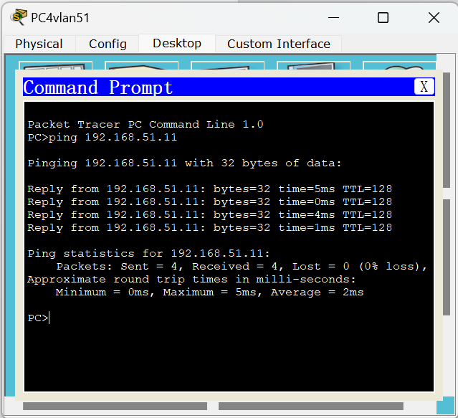

**图2.10 PC4vlan51测试机跨交换机相同VLAN主机连通性测试**

* 不同交换机内不同VLAN主机的连通性

PC3vlan50：

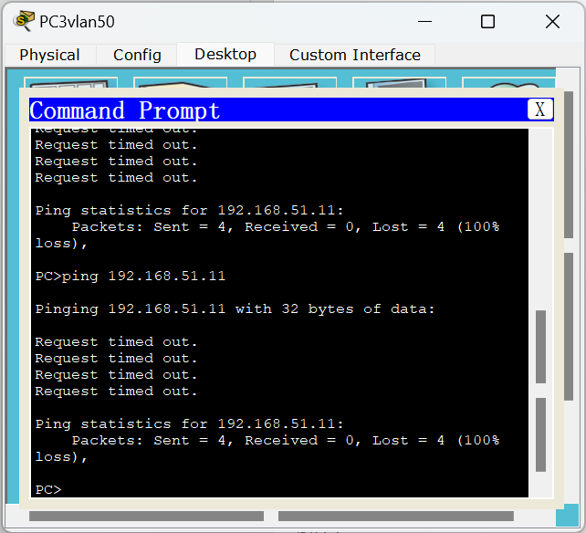

**图2.11 PC3vlan50测试机跨交换机不同VLAN主机连通性测试**

PC1vlan51：

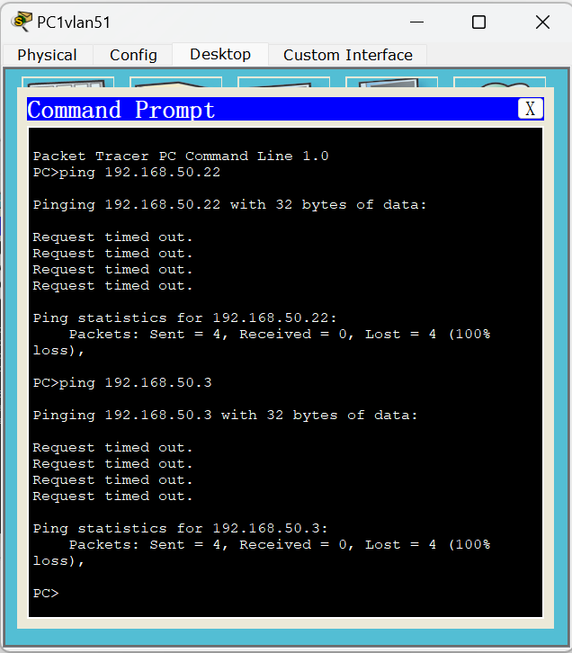

**图2.12 PC1vlan51测试机跨交换机不同VLAN主机连通性测试**

## 实验三 网络互连综合实验

1. 小组成员

小组成员：陈梓欣、明鑫、尹璐、郑羽婷、曲文新。

所属组别：E组。

2. 实验目的

1. 掌握利用三层交换机实现不同VLAN间通信的方法。
2. 掌握路由器基本配置方法。
3. 掌握静态路由和动态路由的配置方法。

3．实验内容和步骤

实验3.1

画出所用的网络拓扑结构图。



**图3.1 跨交换机实现VLAN实验拓扑**

写出：

1. 所有的配置过程。（如实验过程中遇到问题，写出问题原因及解决方法）

在三层交换机上：

switch0>en

switch0#config terminal

Enter configuration commands, one per line. End with CNTL/Z.

修改交换机名称为switchA

switch0(config)#ho switchA

建立一个VLAN 50

switchA(config)#vlan 50

switchA(config-vlan)#na vlan50

把端口fastethernet 0/1加入进vlan 50

switchA(config-vlan)#in fa 0/1

switchA(config-if)#switchport access vlan 50

switchA(config-if)#exit

建立一个VLAN 51

switchA(config)#vlan 51

switchA(config-vlan)#na vlan51

把端口fastethernet 0/2加入进vlan 51

switchA(config-vlan)#in fa 0/2

switchA(config-if)#switchport access vlan 51

switchA(config-if)#exit

switchA(config)#in fa 0/3

switchA(config-if)#exit

switchA(config)#exit

创建虚拟接口vlan 50

switchA(config)#in vlan 50

switchA(config-if)#

%LINK-5-CHANGED: Interface Vlan50, changed state to up

%LINEPROTO-5-UPDOWN: Line protocol on Interface Vlan50, changed state to up

配置虚拟接口vlan 50的IP地址192.168.50.1

switchA(config-if)#ip address 192.168.50.1 255.255.255.0

开启端口

switchA(config-if)#no shutdown

switchA(config-if)#exit

创建虚拟接口vlan 51

switchA(config)#in vlan 51

switchA(config-if)#

%LINK-5-CHANGED: Interface Vlan51, changed state to up

%LINEPROTO-5-UPDOWN: Line protocol on Interface Vlan51, changed state to up

配置虚拟接口vlan 51的IP地址192.168.51.1

switchA(config-if)#ip address 192.168.51.1 255.255.255.0

开启端口

switchA(config-if)#no shutdown

switchA(config-if)#exit

在二层交换机上：

switch1#config terminal

Enter configuration commands, one per line. End with CNTL/Z.

修改交换机名称为 switchB

switch1(config)#ho switchB

建立一个VLAN 50

switchB(config)#vlan 50

switchB(config-vlan)#na vlan50

把端口fastethernet 0/2加入进vlan 50

switchB(config-vlan)#in fa 0/2

switchB(config-if)#switchport access vlan 50

把端口fastethernet 0/4加入进vlan 50

switchB(config-vlan)#in fa 0/4

switchB(config-if)#switchport access vlan 50

switchB(config-if)#exit

建立一个VLAN 51

switchB(config)#vlan 51

switchB(config-vlan)#na vlan51

把端口fastethernet 0/1加入进vlan 51

switchB(config-vlan)#in fa 0/1

switchB(config-if)#switchport access vlan 51

switchB(config-if)#exit

把两个交换机相连的端口fastethernet 0/3设置为trunk方式

switchB(config)#in fa 0/3

switchB(config-if)#switchport mode trunk

switchB(config-if)#exit

switchB(config)#exit

创建虚拟接口vlan 50

switchB(config)#in vlan 50

switchB(config-if)#

%LINK-5-CHANGED: Interface Vlan50, changed state to up

%LINEPROTO-5-UPDOWN: Line protocol on Interface Vlan50, changed state to up

配置虚拟接口vlan 50的IP地址192.168.50.2

switchB(config-if)#ip address 192.168.50.2 255.255.255.0

开启端口

switchB(config-if)#no shutdown

switchB(config-if)#exit

创建虚拟接口vlan 51

switchB(config)#in vlan 51

switchB(config-if)#

%LINK-5-CHANGED: Interface Vlan51, changed state to up

%LINEPROTO-5-UPDOWN: Line protocol on Interface Vlan51, changed state to up

配置虚拟接口vlan 50的IP地址192.168.50.2

switchB(config-if)#ip address 192.168.51.2 255.255.255.0

开启端口

switchB(config-if)#no shutdown

switchB(config-if)#exit

1. 写出配置成功后，三层交换机执行“show running-config”、“show ip route”和“show ip interface brief”后的结果；二层交换机执行show vlan”、“show running-config”后的结果。
2. 对三层交换机（switchA）

* show running-config

switchA#show running-config

Building configuration...

Current configuration : 1365 bytes

!

version 12.2

no service timestamps log datetime msec

no service timestamps debug datetime msec

no service password-encryption

!

hostname switchA

!

!

!

!

!

!

!

!

!

!

!

!

!

!

!

!

!

!

!

!

spanning-tree mode pvst

!

!

!

!

!

!

interface FastEthernet0/1

switchport access vlan 50

duplex half

speed 10

!

interface FastEthernet0/2

switchport access vlan 51

duplex half

speed 10

!

interface FastEthernet0/3

duplex half

speed 10

!

interface FastEthernet0/4

!

interface FastEthernet0/5

!

interface FastEthernet0/6

!

interface FastEthernet0/7

!

interface FastEthernet0/8

!

interface FastEthernet0/9

!

interface FastEthernet0/10

!

interface FastEthernet0/11

!

interface FastEthernet0/12

!

interface FastEthernet0/13

!

interface FastEthernet0/14

!

interface FastEthernet0/15

!

interface FastEthernet0/16

!

interface FastEthernet0/17

!

interface FastEthernet0/18

!

interface FastEthernet0/19

!

interface FastEthernet0/20

!

interface FastEthernet0/21

!

interface FastEthernet0/22

!

interface FastEthernet0/23

!

interface FastEthernet0/24

!

interface GigabitEthernet0/1

!

interface GigabitEthernet0/2

!

interface Vlan1

no ip address

shutdown

!

interface Vlan50

ip address 192.168.50.1 255.255.255.0

!

interface Vlan51

ip address 192.168.51.1 255.255.255.0

!

ip classless

!

ip flow-export version 9

!

!

!

!

!

!

!

line con 0

!

line aux 0

!

line vty 0 4

login

!

!

!

End

* show ip route

switchA#show ip route

Codes: C - connected, S - static, I - IGRP, R - RIP, M - mobile, B - BGP

D - EIGRP, EX - EIGRP external, O - OSPF, IA - OSPF inter area

N1 - OSPF NSSA external type 1, N2 - OSPF NSSA external type 2

E1 - OSPF external type 1, E2 - OSPF external type 2, E - EGP

i - IS-IS, L1 - IS-IS level-1, L2 - IS-IS level-2, ia - IS-IS inter area

* - candidate default, U - per-user static route, o - ODR

P - periodic downloaded static route

Gateway of last resort is not set

C 192.168.50.1/24 is directly connected, Vlan50

C 192.168.51.1/24 is directly connected, Vlan51

* show ip interface brief

switchA#show ip interface brief

Interface IP-Address OK? Method Status Protocol

FastEthernet0/1 unassigned YES unset up up

FastEthernet0/2 unassigned YES unset up up

FastEthernet0/3 unassigned YES unset up up

FastEthernet0/4 unassigned YES unset down down

FastEthernet0/5 unassigned YES unset down down

FastEthernet0/6 unassigned YES unset down down

FastEthernet0/7 unassigned YES unset down down

FastEthernet0/8 unassigned YES unset down down

FastEthernet0/9 unassigned YES unset down down

FastEthernet0/10 unassigned YES unset down down

FastEthernet0/11 unassigned YES unset down down

FastEthernet0/12 unassigned YES unset down down

FastEthernet0/13 unassigned YES unset down down

FastEthernet0/14 unassigned YES unset down down

FastEthernet0/15 unassigned YES unset down down

FastEthernet0/16 unassigned YES unset down down

FastEthernet0/17 unassigned YES unset down down

FastEthernet0/18 unassigned YES unset down down

FastEthernet0/19 unassigned YES unset down down

FastEthernet0/20 unassigned YES unset down down

FastEthernet0/21 unassigned YES unset down down

FastEthernet0/22 unassigned YES unset down down

FastEthernet0/23 unassigned YES unset down down

FastEthernet0/24 unassigned YES unset down down

GigabitEthernet0/1 unassigned YES unset down down

GigabitEthernet0/2 unassigned YES unset down down

Vlan1 unassigned YES unset administratively down down

Vlan50 192.168.50.1 YES manual up up

Vlan51 192.168.51.1 YES manual up up

1. 对二层交换机（switchB）

* show running-config

switchB#show running-config

Building configuration...

Current configuration : 1290 bytes

!

version 12.1

no service timestamps log datetime msec

no service timestamps debug datetime msec

no service password-encryption

!

hostname switchB

!

!

!

spanning-tree mode pvst

!

interface FastEthernet0/1

switchport access vlan 51

duplex half

speed 10

!

interface FastEthernet0/2

switchport access vlan 50

duplex half

speed 10

!

interface FastEthernet0/3

switchport mode trunk

duplex half

speed 10

!

interface FastEthernet0/4

switchport access vlan 50

duplex half

speed 10

!

interface FastEthernet0/5

!

interface FastEthernet0/6

!

interface FastEthernet0/7

!

interface FastEthernet0/8

!

interface FastEthernet0/9

!

interface FastEthernet0/10

!

interface FastEthernet0/11

!

interface FastEthernet0/12

!

interface FastEthernet0/13

!

interface FastEthernet0/14

!

interface FastEthernet0/15

!

interface FastEthernet0/16

!

interface FastEthernet0/17

!

interface FastEthernet0/18

!

interface FastEthernet0/19

!

interface FastEthernet0/20

!

interface FastEthernet0/21

!

interface FastEthernet0/22

!

interface FastEthernet0/23

!

interface FastEthernet0/24

!

interface Vlan1

no ip address

shutdown

!

interface Vlan50

ip address 192.168.50.2 255.255.255.0

!

interface Vlan51

ip address 192.168.51.2 255.255.255.0

!

!

!

!

line con 0

!

line vty 0 4

login

line vty 5 15

login

!

!

end

* show vlan

switchB#show vlan

VLAN Name Status Ports

---- -------------------------------- --------- -------------------------------

1 default active Fa0/5, Fa0/6, Fa0/7, Fa0/8

Fa0/9, Fa0/10, Fa0/11, Fa0/12

Fa0/13, Fa0/14, Fa0/15, Fa0/16

Fa0/17, Fa0/18, Fa0/19, Fa0/20

Fa0/21, Fa0/22, Fa0/23, Fa0/24

50 vlan50 active Fa0/2, Fa0/4

51 vlan51 active Fa0/1

1002 fddi-default act/unsup

1003 token-ring-default act/unsup

1004 fddinet-default act/unsup

1005 trnet-default act/unsup

VLAN Type SAID MTU Parent RingNo BridgeNo Stp BrdgMode Trans1 Trans2

---- ----- ---------- ----- ------ ------ -------- ---- -------- ------ ------

1 enet 100001 1500 - - - - - 0 0

50 enet 100050 1500 - - - - - 0 0

51 enet 100051 1500 - - - - - 0 0

1002 fddi 101002 1500 - - - - - 0 0

1003 tr 101003 1500 - - - - - 0 0

1004 fdnet 101004 1500 - - - ieee - 0 0

1005 trnet 101005 1500 - - - ibm - 0 0

Remote SPAN VLANs

------------------------------------------------------------------------------

Primary Secondary Type Ports

------- --------- ----------------- ------------------------------------------

* show ip interface brief

switchB#show ip interface brief

Interface IP-Address OK? Method Status Protocol

FastEthernet0/1 unassigned YES manual up up

FastEthernet0/2 unassigned YES manual up up

FastEthernet0/3 unassigned YES manual up up

FastEthernet0/4 unassigned YES manual up up

FastEthernet0/5 unassigned YES manual down down

FastEthernet0/6 unassigned YES manual down down

FastEthernet0/7 unassigned YES manual down down

FastEthernet0/8 unassigned YES manual down down

FastEthernet0/9 unassigned YES manual down down

FastEthernet0/10 unassigned YES manual down down

FastEthernet0/11 unassigned YES manual down down

FastEthernet0/12 unassigned YES manual down down

FastEthernet0/13 unassigned YES manual down down

FastEthernet0/14 unassigned YES manual down down

FastEthernet0/15 unassigned YES manual down down

FastEthernet0/16 unassigned YES manual down down

FastEthernet0/17 unassigned YES manual down down

FastEthernet0/18 unassigned YES manual down down

FastEthernet0/19 unassigned YES manual down down

FastEthernet0/20 unassigned YES manual down down

FastEthernet0/21 unassigned YES manual down down

FastEthernet0/22 unassigned YES manual down down

FastEthernet0/23 unassigned YES manual down down

FastEthernet0/24 unassigned YES manual down down

Vlan1 unassigned YES manual administratively down down

Vlan50 192.168.50.2 YES manual up up

Vlan51 192.168.51.2 YES manual up up

1. 测试连通性的结果（截图）。
2. 网络设备配置好后，对选定的测试主机，禁用“本地连接3”，启用“本地连接4”,并按照实验拓扑图修改1P地址

**表3.1 选定测试主机IP、划分VLAN以及连接的交换机与端口**

**（switchA为三层交换机，switchB为二层交换机）**

|  |  |  |  |  |
| --- | --- | --- | --- | --- |
| PC | IP | VLAN | Switch | Fastethernet |
| PC5vlan50 | 192.168.50.5 | VLAN 50 | switchA | Fa 0/1 |
| PC1vlan51 | 192.168.51.11 | VLAN 51 | switchA | Fa 0/2 |
| PC2vlan50 | 192.168.50.22 | VLAN 50 | switchB | Fa 0/2 |
| PC3vlan50 | 192.168.50.3 | VLAN 50 | switchB | Fa 0/4 |
| PC4vlan51 | 192.168.51.4 | VLAN 51 | switchB | Fa 0/1 |
| 作为两个交换机相连的端口，将其设置为trunk方式 | | | | Fa 0/3 |

1. 通过网络命令进行测试（ping命令）:

* 不同交换机内同一个VLAN内主机的连通性

PC4vlan51：



**图3.2 PC4vlan51测试机跨交换机相同VLAN主机连通性测试**

PC5vlan50：



**图3.3 PC5vlan50测试机跨交换机相同VLAN主机连通性测试**

* 不同交换机内不同VLAN主机的连通性

PC3vlan50：



**图3.4 PC3vlan50测试机跨交换机不同VLAN主机连通性测试**

PC1vlan51：



**图3.5 PC1vlan51测试机跨交换机不同VLAN主机连通性测试**

实验3.2

画出所用的网络拓扑结构图。

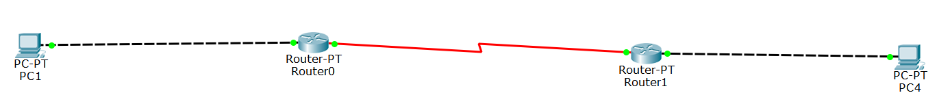

**图3.6 静态路由实验拓扑**

写出：

1. 所有的配置过程。（如实验过程中遇到问题，写出问题原因及解决方法）

路由器A：

配置端口IP地址

Router0(config)#interface fa 0/0

Router0config-if)#ip address 172.16.50.254 255.255.0.0

开启该端口，使端口转发数据

Router0(config-if)#no shutdown

配置DCE端

Router0(config)#interface serial 2/0

Router0(config-if)#ip address 10.10.50.1 255.0.0.0

Router0(config-if)#clock rate 64000

//在DCE端配置时钟频率64000

Router0(config-if)#no shutdown

路由器B：

配置端口IP地址

Router1(config)#interface fa 1/0

Router1(config-if)#ip address 172.31.50.2 255.255.255.0

开启该端口，使端口转发数据

Router1(config-if)#no shutdown

配置DTE端

Router1(config)#interface serial 2/0

Router1(config-if)#ip address 10.10.50.2 255.0.0.0

Router1(config-if)#no shutdown

1. 写出配置成功后，每台设备执行“show running-config”、“show ip route”和“show ip interface brief”后的结果。
2. 路由器A

* show running-config

Router0#show running-config

Building configuration...

Current configuration : 788 bytes

!

version 12.2

no service timestamps log datetime msec

no service timestamps debug datetime msec

no service password-encryption

!

hostname Router0

!

!

!

!

!

!

!

!

ip cef

no ipv6 cef

!

!

!

!

!

!

!

!

!

!

!

!

!

!

!

!

!

!

interface FastEthernet0/0

ip address 172.16.50.254 255.255.0.0

duplex auto

speed auto

!

interface FastEthernet1/0

no ip address

duplex auto

speed auto

shutdown

!

interface Serial2/0

ip address 10.10.50.1 255.0.0.0

clock rate 64000

!

interface Serial3/0

no ip address

clock rate 2000000

shutdown

!

interface FastEthernet4/0

no ip address

shutdown

!

interface FastEthernet5/0

no ip address

shutdown

!

ip classless

ip route 172.31.0.0 255.255.0.0 10.10.50.2

!

ip flow-export version 9

!

!

!

!

!

!

!

line con 0

!

line aux 0

!

line vty 0 4

login

!

!

!

end

* show ip route

Router0#show ip route

Codes: C - connected, S - static, I - IGRP, R - RIP, M - mobile, B - BGP

D - EIGRP, EX - EIGRP external, O - OSPF, IA - OSPF inter area

N1 - OSPF NSSA external type 1, N2 - OSPF NSSA external type 2

E1 - OSPF external type 1, E2 - OSPF external type 2, E - EGP

i - IS-IS, L1 - IS-IS level-1, L2 - IS-IS level-2, ia - IS-IS inter area

* - candidate default, U - per-user static route, o - ODR

P - periodic downloaded static route

Gateway of last resort is not set

C 10.0.0.0/8 is directly connected, Serial2/0

C 172.16.0.0/16 is directly connected, FastEthernet0/0

S 172.31.0.0/16 [1/0] via 10.10.50.2

* show ip interface brief

Router0#show ip interface brief

Interface IP-Address OK? Method Status Protocol

FastEthernet0/0 172.16.50.254 YES manual up up

FastEthernet1/0 unassigned YES unset administratively down down

Serial2/0 10.10.50.1 YES manual up up

Serial3/0 unassigned YES unset administratively down down

FastEthernet4/0 unassigned YES unset administratively down down

FastEthernet5/0 unassigned YES unset administratively down down

1. 路由器B

* show running-config

Router1#show running-config

Building configuration...

Current configuration : 770 bytes

!

version 12.2

no service timestamps log datetime msec

no service timestamps debug datetime msec

no service password-encryption

!

hostname Router1

!

!

!

!

!

!

!

!

ip cef

no ipv6 cef

!

!

!

!

!

!

!

!

!

!

!

!

!

!

!

!

!

!

interface FastEthernet0/0

no ip address

duplex auto

speed auto

shutdown

!

interface FastEthernet1/0

ip address 172.31.50.254 255.255.0.0

duplex auto

speed auto

!

interface Serial2/0

ip address 10.10.50.2 255.0.0.0

!

interface Serial3/0

no ip address

clock rate 2000000

shutdown

!

interface FastEthernet4/0

no ip address

shutdown

!

interface FastEthernet5/0

no ip address

shutdown

!

ip classless

ip route 172.16.0.0 255.255.0.0 10.10.50.1

!

ip flow-export version 9

!

!

!

!

!

!

!

line con 0

!

line aux 0

!

line vty 0 4

login

!

!

!

end

* show ip route

Router1#show ip route

Codes: C - connected, S - static, I - IGRP, R - RIP, M - mobile, B - BGP

D - EIGRP, EX - EIGRP external, O - OSPF, IA - OSPF inter area

N1 - OSPF NSSA external type 1, N2 - OSPF NSSA external type 2

E1 - OSPF external type 1, E2 - OSPF external type 2, E - EGP

i - IS-IS, L1 - IS-IS level-1, L2 - IS-IS level-2, ia - IS-IS inter area

* - candidate default, U - per-user static route, o - ODR

P - periodic downloaded static route

Gateway of last resort is not set

C 10.0.0.0/8 is directly connected, Serial2/0

S 172.16.0.0/16 [1/0] via 10.10.50.1

C 172.31.0.0/16 is directly connected, FastEthernet1/0

* show ip interface brief

Router1#show ip interface brief

Interface IP-Address OK? Method Status Protocol

FastEthernet0/0 unassigned YES unset administratively down down

FastEthernet1/0 172.31.50.254 YES manual up up

Serial2/0 10.10.50.2 YES manual up up

Serial3/0 unassigned YES unset administratively down down

FastEthernet4/0 unassigned YES unset administratively down down

FastEthernet5/0 unassigned YES unset administratively down down

1. 测试连通性的结果（截图）。
2. 对选定的测试主机，禁用“本地连接3”，启用“本地连接4”,并按照实验拓扑图修改1P地址

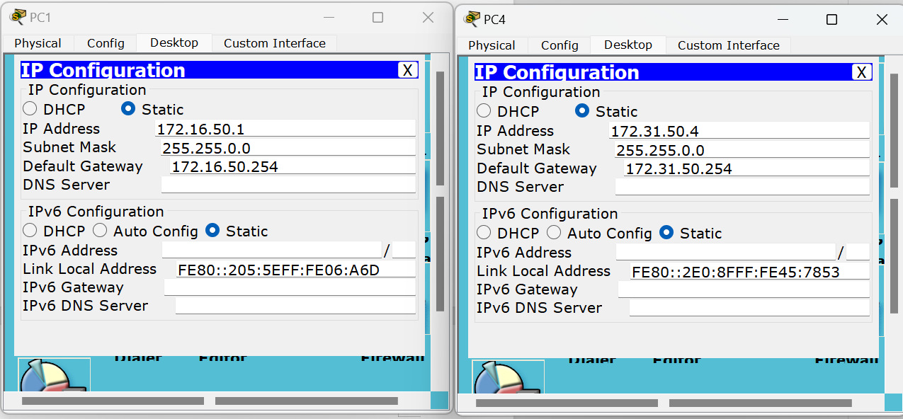

**图3.7 测试主机IP、子网掩码、网关修改示意**

1. 通过网络命令进行测试（ping命令）

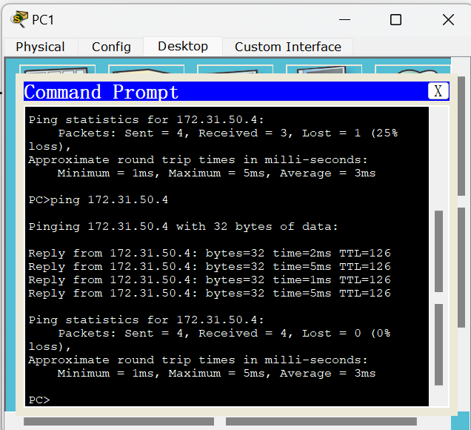

**图3.8 不同路由测试机在静态路由条件下连通性测试**

实验3.3

画出所用的网络拓扑结构图。

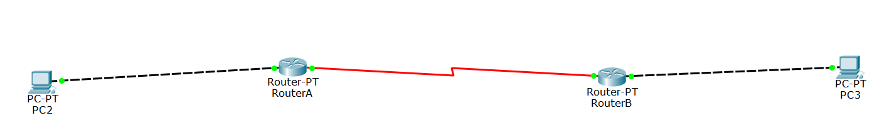

**图3.9 RIP路由实验拓扑**

写出：

1. 所有的配置过程。（如实验过程中遇到问题，写出问题原因及解决方法）

RouterA

配置端口IP

Router(config)#ho RouterA

RouterA(config)#

RouterA(config)#int fa 0/0

RouterA(config-if)#ip add 172.16.51.254 255.255.0.0

RouterA(config-if)#no sh

RouterA(config-if)#

配置DCE端

RouterA(config-if)#int sa 3/0

RouterA(config-if)#ip add 10.10.51.1 255.0.0.0

RouterA(config-if)#clock rate 64000

//在DCE端配置时钟频率64000

RouterA(config-if)#no sh

RouterB配置端口IP

Router#conf t

Enter configuration commands, one per line. End with CNTL/Z.

Router(config-if)#ho RouterB

RouterB(config)#

RouterB(config)#

RouterB(config)#in fa 1/0

RouterB(config-if)#ip add 172.31.51.254 255.255.0.0

RouterB(config-if)#no sh

RouterB(config-if)#

%LINK-5-CHANGED: Interface GigabitEthernet0/1, changed state to up

%LINEPROTO-5-UPDOWN: Line protocol on Interface GigabitEthernet0/1, changed state to up

RouterB(config-if)#ex

配置DTE端

RouterB(config)#int sa 3/0

RouterB(config-if)#ip add 10.10.51.2 255.0.0.0

RouterB(config-if)#no sh

配置RIP协议

RouterA(config)#route rip #开启RIP协议

RouterA(config-router)#version 2 #启用RIPv2

RouterA(config-router)#network 172.16.51.254 #宣告网段

RouterA(config-router)#network 10.10.51.1 #宣告网段

RouterA(config-router)#no auto-summary #关闭自动汇总

RouterB(config)#route rip

RouterB(config-router)#v 2

RouterB(config-router)#network 172.31.51.254

RouterB(config-router)#network 10.10.51.2

RouterB(config-router)#no auto-summary

1. 写出配置成功后，每台设备执行“show running-config”、“show ip route”和“show ip interface brief”后的结果。
2. RouterA路由

* show running-config

RouterA#show running-config

Building configuration...

Current configuration : 823 bytes

!

version 12.2

no service timestamps log datetime msec

no service timestamps debug datetime msec

no service password-encryption

!

hostname RouterA

!

!

!

!

!

!

!

!

ip cef

no ipv6 cef

!

!

!

!

!

!

!

!

!

!

!

!

!

!

!

!

!

!

interface FastEthernet0/0

ip address 172.16.51.254 255.255.0.0

duplex auto

speed auto

!

interface FastEthernet1/0

no ip address

duplex auto

speed auto

shutdown

!

interface Serial2/0

no ip address

clock rate 2000000

shutdown

!

interface Serial3/0

ip address 10.10.51.1 255.0.0.0

clock rate 64000

!

interface FastEthernet4/0

no ip address

shutdown

!

interface FastEthernet5/0

no ip address

shutdown

!

router rip

version 2

network 10.0.0.0

network 172.16.0.0

no auto-summary

!

ip classless

!

ip flow-export version 9

!

!

!

!

!

!

!

line con 0

!

line aux 0

!

line vty 0 4

login

!

!

!

end

* show ip route

RouterA#show ip route

Codes: C - connected, S - static, I - IGRP, R - RIP, M - mobile, B - BGP

D - EIGRP, EX - EIGRP external, O - OSPF, IA - OSPF inter area

N1 - OSPF NSSA external type 1, N2 - OSPF NSSA external type 2

E1 - OSPF external type 1, E2 - OSPF external type 2, E - EGP

i - IS-IS, L1 - IS-IS level-1, L2 - IS-IS level-2, ia - IS-IS inter area

* - candidate default, U - per-user static route, o - ODR

P - periodic downloaded static route

Gateway of last resort is not set

C 10.0.0.0/8 is directly connected, Serial3/0

C 172.16.0.0/16 is directly connected, FastEthernet0/0

R 172.31.0.0/16 [120/1] via 10.10.51.2, 00:00:24, Serial3/0

* show ip interface brief

RouterA#show ip interface brief

Interface IP-Address OK? Method Status Protocol

FastEthernet0/0 172.16.51.254 YES manual up up

FastEthernet1/0 unassigned YES unset administratively down down

Serial2/0 unassigned YES unset administratively down down

Serial3/0 10.10.51.1 YES manual up up

FastEthernet4/0 unassigned YES unset administratively down down

FastEthernet5/0 unassigned YES unset administratively down down

1. RouterB路由

* show running-config

RouterB#show running-config

Building configuration...

Current configuration : 805 bytes

!

version 12.2

no service timestamps log datetime msec

no service timestamps debug datetime msec

no service password-encryption

!

hostname RouterB

!

!

!

!

!

!

!

!

ip cef

no ipv6 cef

!

!

!

!

!

!

!

!

!

!

!

!

!

!

!

!

!

!

interface FastEthernet0/0

no ip address

duplex auto

speed auto

shutdown

!

interface FastEthernet1/0

ip address 172.31.51.254 255.255.0.0

duplex auto

speed auto

!

interface Serial2/0

no ip address

clock rate 2000000

shutdown

!

interface Serial3/0

ip address 10.10.51.2 255.0.0.0

!

interface FastEthernet4/0

no ip address

shutdown

!

interface FastEthernet5/0

no ip address

shutdown

!

router rip

version 2

network 10.0.0.0

network 172.31.0.0

no auto-summary

!

ip classless

!

ip flow-export version 9

!

!

!

!

!

!

!

line con 0

!

line aux 0

!

line vty 0 4

login

!

!

!

end

* show ip route

RouterB#show ip route

Codes: C - connected, S - static, I - IGRP, R - RIP, M - mobile, B - BGP

D - EIGRP, EX - EIGRP external, O - OSPF, IA - OSPF inter area

N1 - OSPF NSSA external type 1, N2 - OSPF NSSA external type 2

E1 - OSPF external type 1, E2 - OSPF external type 2, E - EGP

i - IS-IS, L1 - IS-IS level-1, L2 - IS-IS level-2, ia - IS-IS inter area

* - candidate default, U - per-user static route, o - ODR

P - periodic downloaded static route

Gateway of last resort is not set

C 10.0.0.0/8 is directly connected, Serial3/0

R 172.16.0.0/16 [120/1] via 10.10.51.1, 00:00:26, Serial3/0

C 172.31.0.0/16 is directly connected, FastEthernet1/0

* show ip interface brief

RouterB#show ip interface brief

Interface IP-Address OK? Method Status Protocol

FastEthernet0/0 unassigned YES unset administratively down down

FastEthernet1/0 172.31.51.254 YES manual up up

Serial2/0 unassigned YES unset administratively down down

Serial3/0 10.10.51.2 YES manual up up

FastEthernet4/0 unassigned YES unset administratively down down

FastEthernet5/0 unassigned YES unset administratively down down

1. 测试连通性的结果（截图）。
2. 对选定的测试主机，禁用“本地连接3”，启用“本地连接4”,并按照实验拓扑图修改1P地址

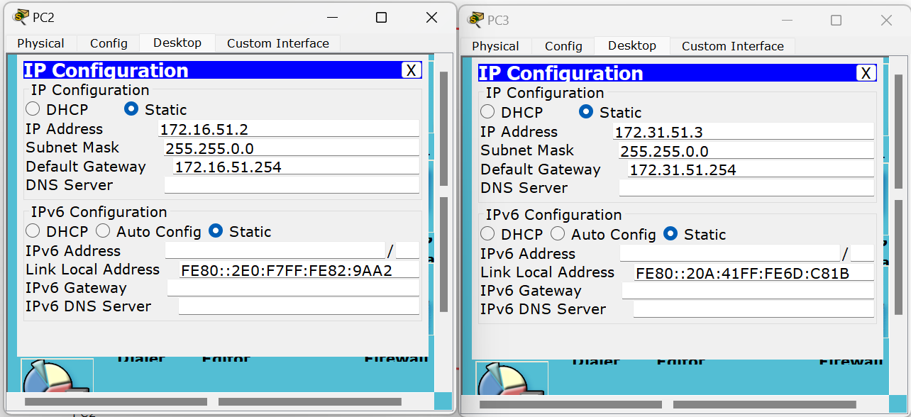

**图3.10 测试主机IP、子网掩码、网关修改示意**

1. 通过网络命令进行测试（ping命令）

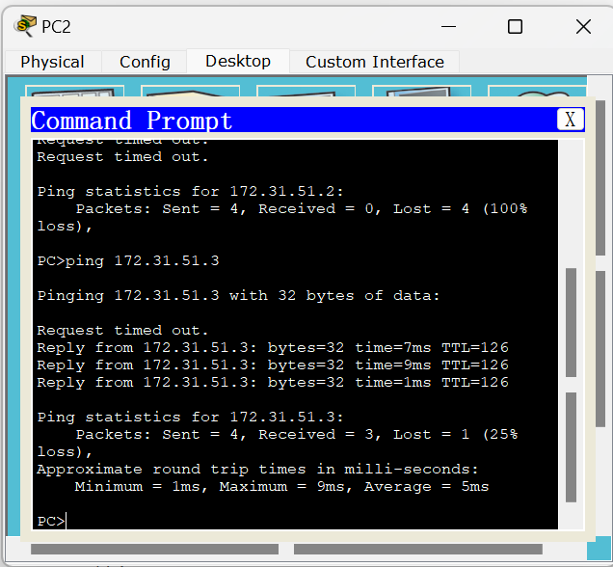

**图3.11 不同路由测试机在RIP路由条件下连通性测试**